FINAL REPORT

from

Investigation of railway accident – derailment of shunting train № 50890 between the stations Kocherinovo – Boboshevo on 31.07.2021

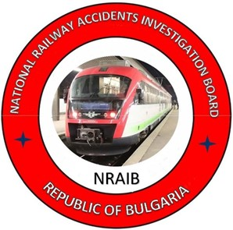

2021
OBJECTIVE OF INVESTIGATION AND EXTENT OF RESPONSIBILITY

The National Air, Maritime and Railway Transport Accidents Investigation Board (NAMRTAIB), which is an independent body performs the investigation of serious accidents and incidents. The National Board is within the Council of Ministers (CM) of the Republic of Bulgaria, and aims to find the circumstances and causes that led to the accidents and incidents occurrence in order to improve the safety and to avoid such in future, without searching personal fault and responsibility.
The investigation is performed in accordance with the requirements of Directive (EU) 2016/798 of the European Parliament and of the Council of 11 May 2016 on railway safety, which is transposed into the Railway Transport Act (RTA), Ordinance No 59 dated 5.12.2006 on the rail transport safety management, and Ordinance No Н-32 dated 19.09.2007 on the coordination of the activities and information exchange during the railway accidents and incidents investigation, as well as per Agreement dated 17.04.2018 on the interaction during investigation of accidents and incidents in the air, maritime and railway transport between the Prosecutor's Office of the Republic of Bulgaria, Ministry of Interior, and the Ministry of Transport, Information Technology and Communications.
The Reports follow the requirements of Regulation (EU) 2020/572 of 24 April 2020 on the reporting structure for railway accident and incident investigation reports.

TABLE OF CONTENTS
№ | Title of section | Pg.
 | Summary | 5
 | Investigation | 8
 | Description of the event | 11
 | Analysis of the event | 18
 | Conclusions | 33
 | Safety recommendations | 38

ABBREVIATIONS, USED IN THE REPORT
BDZ Cargo Ltd. – ,,BDZ-Cargo“ Ltd.
SE NRIC – State enterprise „National railway infrastructure company“ (railway infrastructure manager).
BDZ PS Ltd. – ,,BDZ-Passenger Services“ Ltd.
RAEA – Railway Administration Executive Agency (National safety authority)
NAMRTAIB – National Air, Maritime, and Railway Transport Accidents Investigation Board (Independent Specialized National Investigation Body)
ECM – Entity in Charge of Maintenance
RRI МН-68 – Route Relay Interlocking type МН-68
ST – Shunting train
TF – Task Force
HTM – Heavy Tamping Machine
TOaSAR – Train Operation and Shunting Activity Rules
RITOR – Railway Infrastructure Technical Operation Rules
RRS – Rail Rolling Stock
LDP – BDZ PS Ltd. Locomotive Depot Prescription
SMS – Safety Management System
TMWI – Technician-mechanic wagon inspector
DCCM – Device for communications, connections and messages
RDLD – Relay Device with key/lock dependency
RTA – Railway Transport Act
Ordinance № 59 – Ordinance on the rail transport safety management

- Summary
  - Brief Description of the Event.
On 31.07.2021, at 15:25 p.m. from Blagoevgrad station departed ST No 50890, consisting of 16 tank wagons empty of light fuels, 64 axles, 329 tonnes, towed by train locomotive No98520055155-6 and electric locomotive No 97520061003-1 with locomotive crews of BDZ Cargo Ltd. In locomotive No 97520061003-1 to Dupnitsa station, travelled also the transport crew — shunting person and shunting switchman, also employees of BDZ Cargo Ltd., who composed the train in Blagoevgrad station. The train route is in the direction of Blagoevgrad — Kocherinovo — Boboshevo — Dupnitsa.
At 15:36 p.m. ST No 50890 was accepted at Kocherinovo station on the second main track with a stop and the traffic manager on-duty delivered a traffic order under special conditions “Model II-A” for the crossing along the interstation Kocherinovo — Boboshevo at a speed of up to 60 km/h (due to the limitation of the running speed of all trains and vehicles from 14:00 p.m. by the railway infrastructure manager from 80 to 60 km/h along the abovementioned interstation).
The train departed at 15:37 p.m. from Kocherinovo station with a regular exit signal. In the course of the train movement along Kocherinovo — Boboshevo interstation, about km 107+ 545 the locomotive drivers of the two locomotives felt the locomotives sliding, as the locomotive driver of the leading locomotive No 97520061003-1 started stopping the train with the train brake and the train stopped at km 107+ 500. The shunting crew and the locomotive drivers inspected the train and found that the last 5 wagons of train No 81527852130-8, 337965338, 31527852254-7, 31527851994-9, 82527851614-1 had derailed to the right in the direction of traffic and the track was severely deformed. (Fig. 1.1)
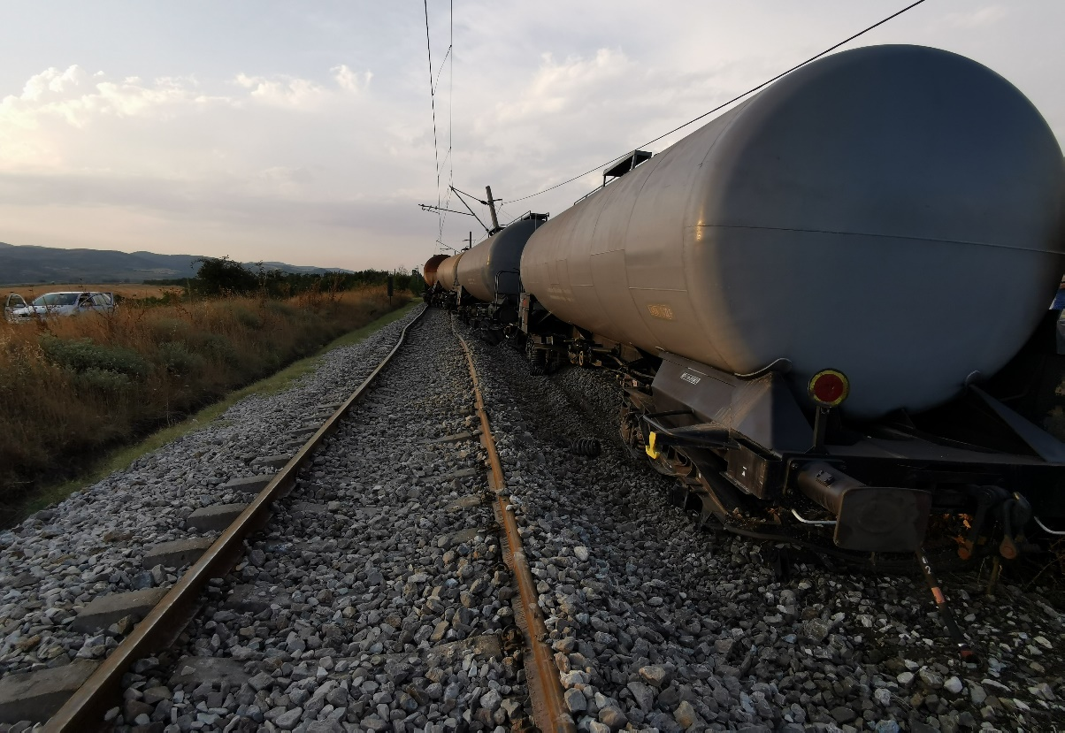
Fig. 1.1. Derailment of 5 wagons from ST № 50890

Because of the derailment, the wagons hit and caused damages to two pillars of the catenary that is hanging. Electric volt arc was caused that ignited dry grasses and shrubs near the track. In order to prevent a fire with the derailed tank wagons of the train, the locomotive drivers together with the shunting crew undertook detachment of the non-derailed 11 wagons and pulled them at a safe distance.
At 19:51 p.m. with an order of the train dispatcher, the interstation Kocherinovo — Boboshevo was closed for movement of all trains and vehicles except the restoratives. At 19:33p.m., the non-derailed 11 wagons of IT No 50890 with the train locomotives were pulled to Boboshevo station and at 19:45 p.m., they departed to the station of Dupnitsa.
To lift the derailed on the rail track wagons, SE NRIC has sent from Sofia station a specialised emergency vehicle, UNIMOG, which lifted all the wagons.
The last derailed sixteenth wagon No 82527851614-1 was lifted at 04:05 a.m. and pulled to Boboshevo station at 04:40 a.m. on 01.08.2021.
By order of the train dispatcher at 10:47 a.m. on 01.08.2021, the train movement along Boboshevo — Kocherinovo station was restored at a speed of 25 km/h from km 107+ 500 to km 107+ 800.
  - Location and time of the event occurrence.
During the movement of FT No 50890 with a speed of 54 km/h along the interstation Kocherinovo — Boboshevo at 15:55 p.m. on km 107+ 693 below the train composition, occurred horizontal two-sided twisting of the track, followed by the derailment of the fourteenth tank wagon No 31527852254-7, followed by the fifteenth, and sixteenth tank wagons, which also derailed with all the wheel-sets on the right. The fifteenth wagon No 315278519994-9 hit and broke two pillars of the catenary. After 70 metres at km 107+ 623, two more tank wagons derailed twelfth and thirteenth of the train composition with one bogie, because of a lighter horizontal distortion of the track. The train stopped at km 107+ 500 (Figure 1.2).

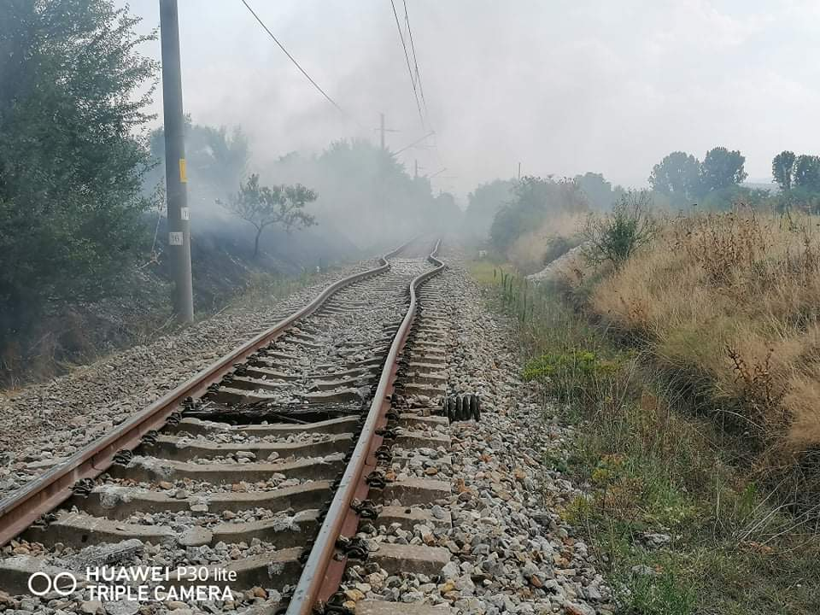
Fig. 1.2 Place of derailment because of the track distortion

1.3. Factors determining the event.
The determining factor for the accident occurrence is the distortion of the track horizontally, across the track axis, due to the increase in the air temperature, the temperature of the rails respectively (Figure 1.2).
Contributing factors to the occurrence of the accident are:
- Non-performed neutralization and ballasting of the track;
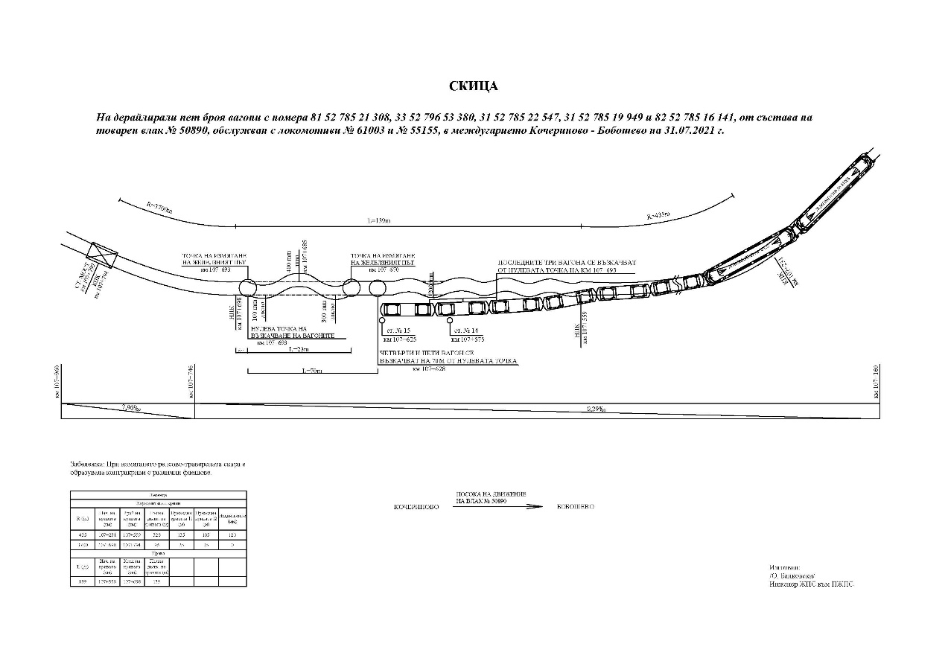
- Necessary repair has been carried out at the place of the accident without compulsory neutralisation and additional ballasting of the stripped sleepers of the track, as well as hastily/untimely increasing of the scheduled speed before the track was strengthened.
Fig. 1.2. Sketch of the accident – derailment of 5 wagons in Kocherinovo-Boboshevo interstation on 31.07.2021
  - Direct causes and consequences of the event.
The most probable direct cause for the occurrence of the accident is the distortion of the track horizontally, across the track axis due to the increased air temperature, and the rail temperature respectively.
It has not been taken into account that the dimensions of the ballast prism do not comply with the regulatory requirements. There has not been performed mandatory neutralisation of the track and additional ballasting. After the operation of the HTM, the adhesion between the sleepers and the ballast prism has been reduced. The running speed has been restored to the scheduled nominal value. Because of these gaps, additional voltages occurred in the non-strained track after the air temperature (on the rails) increased, resulting in a transversal horizontal displacement of the same under the IT No 50890.

1.5. Safety recommendations and addressees to which they are addressed.
The Investigation Commission proposes safety recommendations addressed to the National Safety Authority, the Railway Administration Executive Agency, and relevant to both entities involved in the accident.
• Recommendation 1 proposes that SE NRIC and BDZ Cargo Ltd. shall acquaint the interested staff with the content of this report.
• Recommendation 2 proposes SE NRIC to strengthen the control on places with continuously welded rail track for strict compliance with the “Technical norms for the planning, construction and repair of continuously welded rail track.
• Recommendation 3 proposes that SE NRIC strengthen the control of the state of the continuously welded rail track, especially at extreme temperatures during the summer season based on weather forecasts, by carrying out additional on-the-spot checks and inspections. Particular attention shall be paid to the ballasting and fastening of the rail track.
- Investigation
  - Decision for starting the investigation.
The decision to initiate an investigation of the accident has been taken with respect to the seriousness and its impact on the safety. The investigation aims to prevent this type of accidents, which in similar circumstances could lead to significant accidents, including technical damages in the structural subsystems.
  - Motives for the decision to initiate the investigation.
The Decision to initiate the investigation is based on art. 20, paragraph 2, (а) and (c) of Directive (EU) 2016/798, art. 115к, paragraph 1, item 2 of RTA, art. 76, par. 1, item 2 of Ordinance No 59 dated 5.12.2006, and by Order of the NAMRATIB for assignment of Commission for investigation of the railway accident.
  - Scope and restrictions of the investigation.
The scope of the investigation examined the seriousness of the accident and analysed the railway safety breaches to the operation of the railway infrastructure in connection with its repair and maintenance.
In view of the damages to the rolling stock and the railway infrastructure, the investigation is focused on the circumstances that led to the derailment of the last five tank wagons of IT No50890 in the Kocherinovo — Boboshevo interstation.
  - Competences of the persons, involved in the investigation.
The composition of the commission includes external independent experts - habilitated persons from the higher scientific circles and experts with free profession with qualification and professional orientation in fields of activity – railway infrastructure, and rail rolling stock.
  - Communication and consultations with the persons and entities, involved in the event.
The Task Force, which includes representatives from both entities, was consulted during the investigation. The Head of the Task Force has collected all the documents and templates as well as the downloaded recordings from the recording devices of the two locomotives. These have been submitted to the Chairperson of the Investigation Commission in the NAMRATIB. Interviews were conducted with persons directly involved in the accident. The entities were requested and provided information on the maintenance and repair of the rail track between Kocherinovo and Boboshevo stations, as well as information on the repair and maintenance of the derailed five wagons. Interviews were conducted with the safety authorities of the two entities and with the managers of the railway undertaking BDZ-Cargo Ltd.
  - Degree of cooperation from the participating entities.
During the investigation, the entities BDZ-Cargo Ltd., SE NRIC and the appointed Task Force fully cooperated with the Investigation Commission in the NAMRATIB.
Additional documents and materials were provided to the Commission on establishing the circumstances and causes for the accident
  - Methods and techniques of investigation and analysis.
Following notification under Article 69 par. 2 of Ordinance No 59 by the railway infrastructure manager at 16:13 p.m. on 31.07.2021, the member of the Management Board of the NAMRATIB, competent to investigate railway accidents, analysed the information and departed for the place of the accident with an external expert. On-the-spot meetings and discussions were held with representatives of the investigating authorities of the Rila Regional Dpt. of the Ministry of Interior in connection with their accident investigation and follow-up, as well as with the supervising prosecutor from the Dupnitsa District Prosecutor’s Office.
After the inspections and on-the-spot analysis carried out, the member of the Management Board of the NAMRATIB, in accordance with Article 71 par.2 of Ordinance No 59, classified the event and informed the entities involved in the accident (SE NRIC and BDZ-Cargo Ltd.) of the decision to undertake an investigation.
In accordance with the requirements of Article 25 paragraph 1 of Directive 2016/798 and Article 80 of Ordinance No 59, on 02.08. 2021 the event was notified to the European Railway Agency (ERA) under No BG 10101, an investigation of railway accident by NIB - BG.
The proposal of SE NRIC, the first 11 non-derailment wagons with the two locomotives, to be withdrawn at Boboshevo station was agreed. The last five derailed wagons of the train were left in place.
The first interviews were conducted with the staff involved in the accident by the two entities. Inspections were carried out on the first derailed fourteenth wagon of IT No 50890 and the derailment area, as well as the damaged rail track in the Kocherinovo — Boboshevo interstation. A comprehensive inspection of the damaged railway infrastructure at the station was carried out. The recordings were requested to be downloaded from the recording devices of the two locomotives for decryption.
On 31.07.2021, at 21:10 p.m., a measurement of the track was carried out, for which a statement of findings on the state of the rail track was drawn up in the presence of representatives from the Task force of the two entities.
On 05.08.2021, in the Locomotive depot Dupnitsa, in the presence of representatives of the Task force of the two entities, inspections and measurements were carried out on the five tank wagons derailed with №№ 81527852130-8, 33527965338, 31527852254-7, 31527851994-9, 82527851614-1, and statements of findings on their technical condition were prepared.
On 07.08.2021, additional documents were requested from the railway infrastructure manager concerning the latest track measurements of the railway section — Sofia and the latest measurement with the Track Measuring Laboratory.
On 08.08.2021 BDZ-Cargo Ltd. was asked the request to the SE NRIC for the appointment of the IT No 50890 with the route Blagoevgrad — Kocherinovo — Boboshevo — Dupnitsa.
The Investigation Commission analysed the data downloaded from the recording devices of the two locomotives, electrical No 97520061003-1 and diesel No 98520055155-6 to establish the running speed of IT No 50890 on 31.07.2021 from Kocherinovo station to the stop point of the locomotives.
In connection with Article 73 par. 3 of Ordinance No 59, due to non-compliance with the deadline for the provision of the necessary information by the two entities involved in the accident, by letter No 115/09.08.2021, the Head of the Task Force requested an extension of the deadline from the Chairperson of the Investigation Commission in the NAMRATIB, who granted the authorisation.
On 24.08.2021, in the Sofia RIST, the Chairperson of the Investigation Commission in the NAMRATIB received the collected documentation submitted by the Head of the Task Force II category concerning accident — derailment of five wagons of IT No 50890 at the interstation of Kocherinovo — Boboshevo, around 15:55 p.m. on 31.07.2021.
  - Difficulties faced during the investigation.
During the investigation, communication between the Investigation Commission and the Head of the Task Force was at the necessary level. The railway infrastructure restoration activities started after a written authorisation from the investigating bodies of the Ministry of Interior — Rila and the NAMRATIB.
  - Interaction with the judicial authorities.
In accordance with the Agreement on Interaction with the judicial authorities, following their inspections of the railway infrastructure and the derailed RRS, it was released from supervision and the Investigation Commission started its independent investigation. In the course of investigation was exchanged information with the judicial authorities.
  - Other important information for the investigation context.
After the withdrawal of the non-derailed 11 wagons from IT No 50890 in Boboshevo station, the five wagons remained derailed at the place of the accident. The railway infrastructure manager has set up an organisation for the rapid restoration of railway infrastructure and capacity. The twelfth and thirteenth tank wagons were first lifted, derailed with one bogie, and then pulled to Boboshevo station. An organisation has been set up to lift the remote three tank wagons from the rail track. The last sixteenth tank wagon was lifted at 04:40 a.m. on 01.08.2021, train movement between Kocherinovo and Boboshevo stations was restored at 10:47 a.m. on 01.08.2021 with 25 km/h.
- Description of the event
  - Information on the event and the context.
    - Description of the event type.
On 31.07.2021, at 13:45 p.m., BDZ-Cargo Ltd. submitted application No 1 to SE NRIC for drawing up a traffic schedule for a shunting train of empty tank wagons leaving the branch of a shunting area in Petrol base in Blagoevgrad with route Blagoevgrad — Kocherinovo — Boboshevo — Dupnitsa. The train dispatcher appointed IT No 50890 and at 15:25 p.m., the train departed from Blagoevgrad station. Train composition 16 empty tank wagons, 64 axles, 329 tonnes, and length 220 metres, towed by two locomotives: train No 98520055155-6 and auxiliary locomotive on head No 97520061003-1 with locomotive crews from BDZ-Cargo Ltd. The railway undertaking BDZ-Cargo Ltd. carried out the transport of IT No 50890.
At 15:36 p.m., the traffic manager on duty at Kocherinovo station arranged a route for acceptance of IT No 50890 at the station on the second main track with stopping. The locomotive driver of locomotive No 97520061003-1 was given a traffic order under special conditions “Model II-A” for the passing along interstation Kocherinovo — Boboshevo at a speed of up to 60 km/h.
On the basis of Telegram No 221/31.07.2021 of the Director of Sofia Railway Section at 14:20 p.m., the train dispatcher ordered the traffic manager on-duty at Kocherinovo station, to issue an order for movement under special conditions “Model II-A” to all passing trains and vehicles, in order to limit the speed of all the trains to 60 km/h along the interstation Kocherinovo — Boboshevo and Boboshevo — Dupnitsa due to reaching critical temperatures of the continuously welded rail track.
At 15:37 pm, after the “Model II-A” was given, the train departed to Boboshevo station with a regular exit signal. While the train was running along Kocherinovo — Boboshevo station, at km 107+ 545 the locomotive drivers of the two locomotives felt a strong swing of the locomotives, as the driver of the lead locomotive 97520061003-1 started stopping the train with the train brake and the train stopped at km 107+ 500. The shunting crew travelling in the train in the cab of locomotive No 97520061003-1, together with the locomotive drivers, found that the last 5 tank wagons with №№ 81527852130-8, 33527965338, 31527852254-7, 31527851994-9, 82527851614-1 derailed to the right in the direction of the train movement. Because of the derailment, the wagons hit pillars of the catenary, which hung and induced an electric volt arc, from which dry grasses and bushes were ignited near the track. In order to prevent fire on the train wagons, locomotive drivers and shunting crew untangled the 11 non-derailed wagons and pulled them at a safe distance. At 19:51 p.m. with an order of the train dispatcher, the interstation between the station of Kocherinovo — Boboshevo was closed for movement of all trains and vehicles except the restorative ones.
Following the on-the-spot inspection by the Investigation Commission, it was found that, at km 107+ 693, the first and second wheel-set of the first bogie and then the second bogie of the fourteenth wagon No 31527852254-7 derailed the last two wagons, which also derailed with all the wheel-sets. The fifteenth wagon No 315278519994-9 hit and broke two pillars of the catenary. After about 70 metres from the first derailment, two more wagons twelfth and thirteenth of the train composition derailed with one bogie. After stopping the train, the rear buffers of the last derailed wagon set at km 107+ 625.
During the train’s running, the speed on the route from Blagoevgrad station to the derailment site along Kocherinovo — Boboshevo interstation at km 107+ 693 was observed and the operation was emergency-free.
      - Circumstances prior the accident.
In the course of the investigation, the Investigation Commission found that the locomotive driver of fast train No 5624, operating on a daily schedule with the route Blagoevgrad — Dupnitsa — Radomir — Pernik — Sofia, during the movement on 29.07.2021 at 20:00 p.m. along Kocherinovo — Boboshevo interstation around km 107+ 500, saw that the rails of the track were severely deformed. He undertook rapid deceleration and the train passed the damaged area with a strong locomotive sliding. Upon arrival of the train at Boboshevo station, the locomotive driver informed the traffic manager on-duty that the track was severely deformed. After the signal received on the spot, the head of the railway section to the Sofia railway section departed. During the inspection, it was found that the track around km 107+ 700 was scattered as a result of the high day-to-day temperatures. At 21:15 p.m., he made an entry in the dispatching order log at Boboshevo station, the trains along the Boboshevo — Kocherinovo interstation to move at a speed of up to 5 km/h from km 107+ 650 to km 107+ 700. On 29.07.2021 the technical manager “Mobile Group” from 22:30 p.m. to 04:40 a.m. the train dispatcher at the section allowed a train possession for operation with HTM-08322 along Kocherinovo — Boboshevo interstation to repair the rail track. Evident from the recordings in the station books, the technical supervisor returned the possession earlier than 3 hours and 40 minutes before the allowed time expired.
After returning to Kocherinovo station at 01:00 a.m. on 30.07.2021, the railway technical manager made an entry in the dispatching order log for the reinstatement of trains as scheduled. Given the length of time he worked in the station, it was most likely that only the return of the track along the axis was carried out
    - Date, punctual time and location of the event.
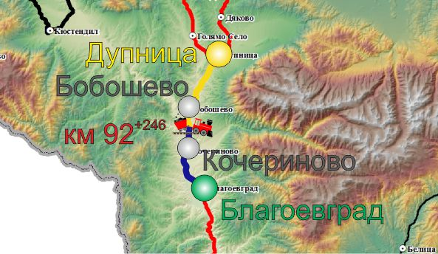
The derailment of IT No 50890 occurred on 31.07.2021 at 15:44 p.m. during its movement at 54 km/h between Kocherinovo and Boboshevo stations at km 107+ 693. The train was running on main railway line 5: Blagoevgrad — Kocherinovo — Boboshevo — Dupnitsa in the direction opposite to the odometer growth (Figure 3.1)
Fig. 3.1. МRoute of movement of train № 50890
- Origin station of the train movement;
- Main stations on the train alignment;
- End destination station for the train movement;
- Place, where the accident occurred;
- Track that the train passed;
- Път, който влакът не е успял да измине.
    - Description of the event location:
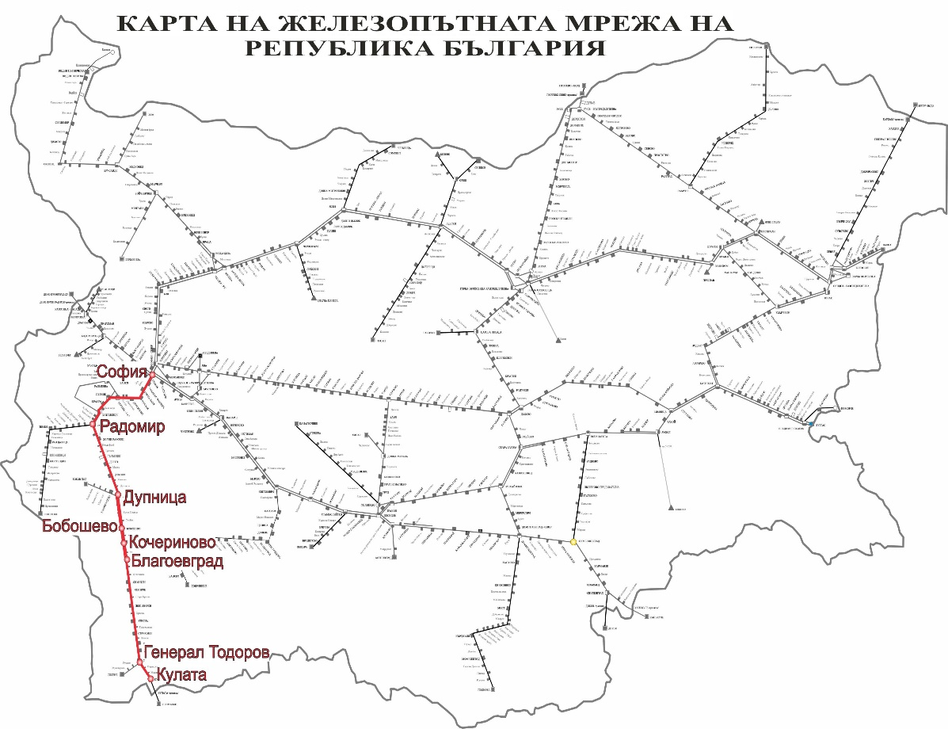
The railway accident occurred between the stations of Kocherinovo and Boboshevo, the rail track is continuously welded in lines with a profile of 0.29 ‰ in downhill. Kocherinovo and Boboshevo stations are located on main railway line 5. Main railway line No 5 is in the direction of Sofia — Pernik — Radomir — Dupnitsa — Blagoevgrad — Kulata, connecting with the Hellenic Republic. The railway is a single-track line, electrified, conventional with speeds of up to 110 km/h (Figure 3.2).
Fig. 3.2. Schematic layout of the main line № 5, along which run IT № 50890.
      - Meteorological and geographical condition at the time of the event.
- In the daylight hours – 15:44 p.m.;
- Air temperature +39ºС;
- Wind speed 1 km/h;
- Weather – clear and hot with normal visibility of the signals;
      - Performance of construction activities on the site or in vicinity.
On 29.07.2021, before the accident occurred along Kocherinovo — Boboshevo interstation, repair works were carried out due to the casting of the track along the axis because of the increased day-to-day air temperatures. The repair was carried out because of a signal from the locomotive driver of fast train No 5624, which passed at 20:00 p.m. on 29.07.2021, for deformations of the rail track along an axis in Kocherinovo — Boboshevo interstation around km 107+ 700.
    - Fatalities, injuries and material damages:
      - Employees of the railway infrastructure manager or railway undertaking.
None.
      - Other persons officially connected with the location of the event.
None.
      - Passengers.
None.
      - External persons.
None.
      - Cargo, luggage or other property.
None.
      - Environment.
None.
      - Rolling stock.
Damages to the running gear of the derailed five wagons No 81527852130-8, 33527965338, 31527852254-7, 31527851994-9 and 82527851614-1;
Damages presented by the railway undertaking BDZ-Cargo Ltd. - BGN 10 243,00;
      - Railway infrastructure.
No damages to the rail track along Kocherinovo — Boboshevo interstation were caused (not represented by the Railway Section - Sofia);
Presented damages for the catenary amounting to BGN 5 304,42;
Total costs: BGN 15 547,42.
    - Description of other consequences, including the event impact on the usual activity of the participants.
In the period 31.07.-01.08.2021, the railway infrastructure manager and the railway undertakings generated additional costs for changing the traffic schedule
      - Railway infrastructure:
- Deviated trains from the alignment: BGN 00,00;
- Cancelled trains along the section: BGN 1 112,74;
- Assigned trains in the section: BGN 38,76;
- Costs for rehabilitation means: BGN 1 631,00;
- Total costs: BGN 2 782,05.
      - Delayed trains of the railway undertakings amounting to – BGN 1 417,05
      - Costs for the railway undertaking BDZ-Cargo Ltd – BGN 3441,27.
    - Identity of the participants and their functions.
      - Railway infrastructure:
- SE National railway infrastructure company has Safety Authorization No № BG 21/2018/0001 valid from 01.07.2018 until 30.06.2023
SE NRIC personnel, involved in the accident:
- Traffic manager on-duty in Kocherinovo station;
- Head of Dupnitsa railway section;
      - Railway undertaking:
- „BDZ-Cargo“ Ltd. has:
    - License for performing railway transport services № 203/31.12.2018;
    - Safety Certificate part А BG 11 2017 0008, valid until 30.12.2022;
    - Safety Certificate part B BG 12 2017 0008, valid until 30.12.2022;
Staff of BDZ-Cargo Ltd., involved in the accident:
- Locomotive driver of locomotive № 97520061003-1;
- Assistant locomotive driver of locomotive № 97520061003-1;
- Locomotive driver of locomotive № 98520055155-6;
    - Description of the respective parts of the railway infrastructure and signalling system:
      - Type of the track, railway switch, rail crossing etc.
Single-track, continuously welded along Kocherinovo-Boboshevo interstation, located in a straight line section, in movement direction with profile 0,29 ‰ in downhill;
      - Interstation block system, station installation, type of signalling.
Kocherinovo-Boboshevo interstation is equipped with semi-automatic block system (SABS);
The stations Kocherinovo and Boboshevo are equipped with station signalling equipment type Relay device for locking/key dependency (RDLD);
      - Train protection systems.
There are no train protection systems on main railway line 5. The Kocherinovo — Boboshevo stations are equipped with a train dispatcher radio (VDRV), with which the locomotive driver performs radio communication with a train dispatcher, and traffic manager on duty in individual stations, with the trains in the respective section. Incoming and outgoing messages are made with a communication device (station concentrator).
Locomotive No 97520061003-1 is equipped with a Hasler RT9 speedometer and a Hasler A16 non-registration speedometer and an active vigilance device.
Locomotive No 98520055155-6 is equipped with RT 12 speedometer and non-registration A 28 and vigilance device active type.
    - Other information about the event.
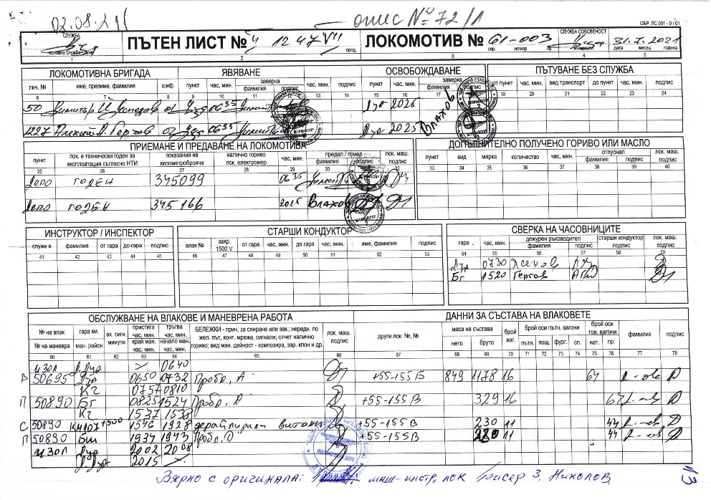
The train documents „Way-bill“ (Fig. 3.5a and b), „Nature sheet“ (Fig. 3.6) and „Brake mass certificate“ (fig. 3.7) corresponding to the vigilance hours of the actual movement of IT №50890 under the presented data of SE NRIC, and the speedometer tape of locomotive № 97520061003-1.
Fig. 3.5.а Way-bill of locomotive № 97520061003-1
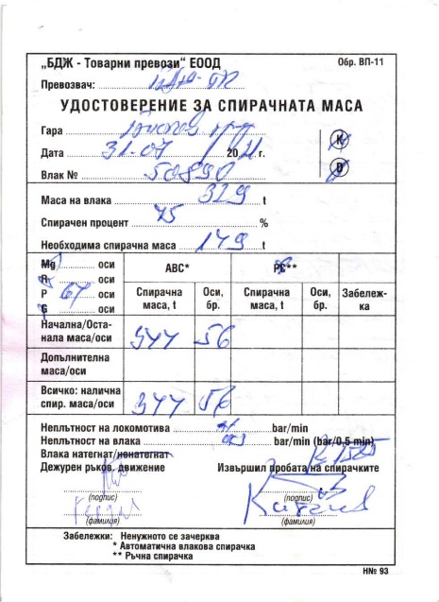
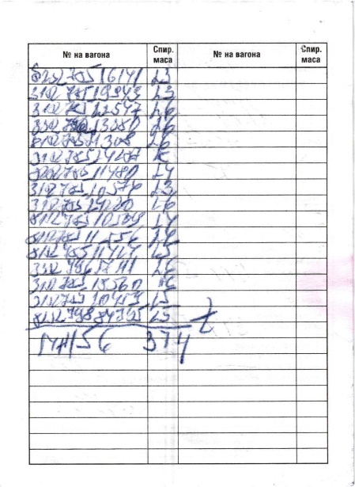
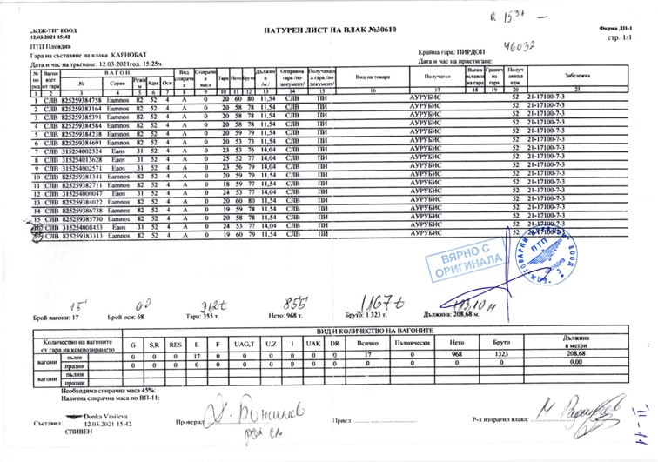
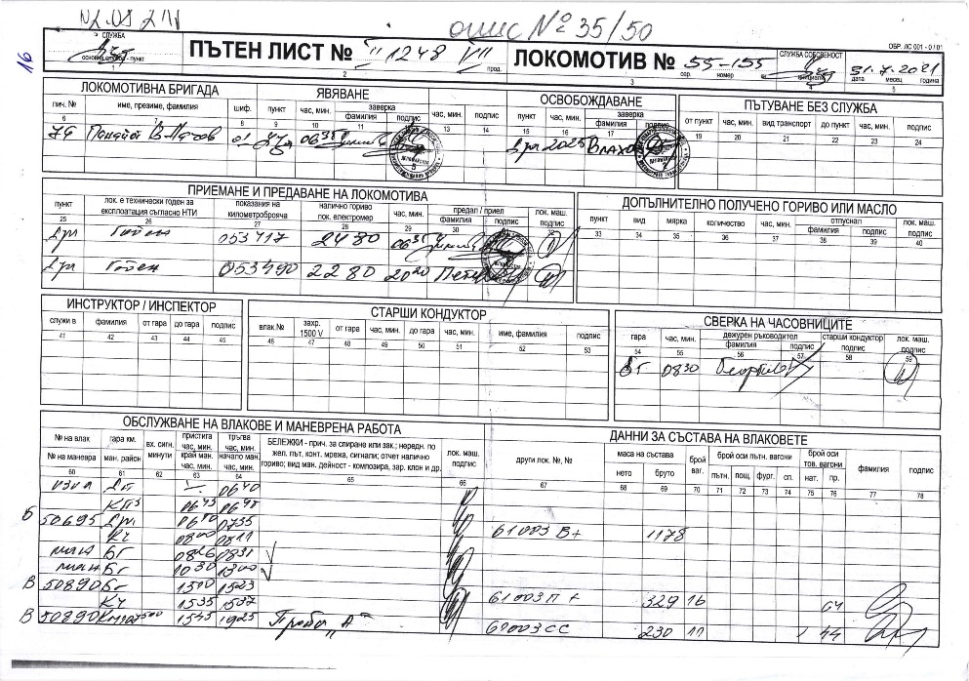
Fig. 3.7. Brake mass certificate of IT № 50890

Fig. 3.6. Nature sheet of IT № 50890
Fig. 3.5.b Way-bill of locomotive № 98520055155-6
  - Factual description of the occurred.
    - Immediate sequence of events that led to the accident, including:
      - Actions that the involved in the event persons undertook.
At 15:36 p.m. IT No 50890 was accepted at Kocherinovo station on the second main track with a stop for reception of the order “Model II-A” of the traffic manager on-duty under special conditions for the crossing of Kocherinovo- Boboshevo interstation at a speed of up to 60 km/h.
At 15:37 p.m., the train departed for Boboshevo station with a regular output signal. When the train run in the Kocherinovo-Boboshevo interstation at a speed of 54 km/h, at km 107+ 545, the locomotive drivers of the two locomotives felt strong swing of the locomotives, the driver of the leading locomotive No 97520061003-1 started stopping the train with the train brake and the train stopped at km 107+ 500. The shunting crew travelling in the train together with the locomotive drivers inspected the train and found that the last 5 wagons derailed to the right in the direction of traffic. The locomotive driver of locomotive No 97520061003-1 informed its managers on the derailed wagons. Because of the derailment, the wagons hit two pillars of the catenary, which hanged and caused an electric volt arc, from which dry grasses and bushes were ignited near the track. The shunting switchman of BDZ-Cargo Ltd. alerted 112 for the fire. In order to prevent a fire on the wagons, the locomotive drivers, together with the shunting crew, detached the 11 non-derailed tank wagons and withdrawn at a safe distance.
      - Rolling stock and technical facilities functioning.
Until the moment of the accident, the rolling stock is regular and functions normally.
The rail track along Kocherinovo — Boboshevo interstation during the passing of IT No50890 was thrown below the composition horizontally, across the axis of the track, and the last 5 wagons of the derailed train.
      - Operational system functioning.
The operational system is regular with proper functions.
    - Sequence of events from the beginning of the accident to the end of the rescue services actions:
At 15:40 p.m., derailed wagon No 31527852254-7 of IT No 50890 while driving along the Kocherinovo — Boboshevo interstation at km 107+ 693 with a speed of 54 km/h;
      - Undertaken measures for protecting and guarding the event location.
The authorities of the RO Ministry of Interior have segregated the area of the accident and the movement of external persons was restricted in order to prevent fire in the derailed tank-wagons (from light fuels), apart from the representatives of the two entities involved in the accident, representatives of the FSaCP and of the NAMRATIB authorities.
      - Actions of the emergency rescue services.
There were not necessary actions of the emergency-rescue services.
The authorities of the FSaCP performed extinguishment of ignited grasses and bushes near the track, as a result from the catenary voltage arc.
      - Actions of the emergency rescue services.
• On 31.07.2021, at 19:00 p.m. at the place of the derailed wagons along the Boboshevo-Kocherinovo interstation, a specialised recovery device UNIMOG from the Sofia Restoration Service arrived and reconstruction work started at 20:00 p.m.
• The non-derailed 11 wagons of IT No 50890 were moved to Boboshevo station at 19:33 p.m. with the two train locomotives. After technical inspection by a mechanic inspecting wagons and drawing up a brake mass certificate VP-11, the train dispatcher authorised the movement of the train to the station of Dupnitsa.
• Following the arrival of IT No 50890 at Dupnitsa station, BDZ Cargo Ltd. submitted a request to the SE NRIC for the preparation of timetables and the appointment of shunting train locomotive No 98520055155-6 in the section Dupnitsa — Boboshevo — Dupnitsa, for the carriage of derailed wagons from the Kocherinovo-Boboshevo station.
• By order of the train dispatcher, IT No 50993 (locomotive No 98520055155-6) was appointed in the Dupnitsa — Boboshevo section. At 20:49 p.m. IT No 50993 departed from to Dupnitsa station. Locomotive No 98520055155-6 departed to Boboshevo -Kocherinovo interstation to km 107+ 500 to collect the derailed wagons from the station
• At 22:13 p.m., the first three derailed wagons with №№ 81527852130-8, 335279653308 and 31527852254-7 were withdrawn by locomotive No 98520055155-6 from the train station in Boboshevo, accompanied by a shunting crew. After technical inspection by a mechanic inspecting wagons and a traffic prescription up to 25 km/h.
• By order of the train dispatcher, IT No 50898 was appointed (locomotive No 98520055155-6) for the carriage of the derailed three wagons No 81527852130-8, 33527965338 and 31527852254-7 to the station of Dupnitsa.
• IT No 50898 departed from Boboshevo station at 22:26 p.m., and arrived at Dupnitsa station at 23:11 p.m.
• At 23:58 p.m. IT No 50999 (locomotive No 98520055155-6) departed from Dupnitsa station to Boboshevo station, to move the remaining two derailed wagons No 31527851994-9 and No 82527851614-1. From the interstation of Kocherinovo — Boboshevo, the derailed wagons were drawn individually to Boboshevo station with locomotive No 98520055155-6, accompanied by a shunting crew with caution.
• The last derailed wagon No. 82527851614-1 was lifted at 04:05 a.m., which was pulled from the station to Boboshevo station at 04:40 a.m. on 01.08.2021
- Analysis of the event
  - Participation and responsibilities of the entities, involved in the event:
    - Railway undertaking.
      - Analysis of the train movement.
IT № 50890 was assigned for movement with telegram № 309/31.07.2021 from Blagoevgrad to Dupnitsa station (fig. 4.1).
Fig. 4.1. Schedule of movement of IT № 50890.
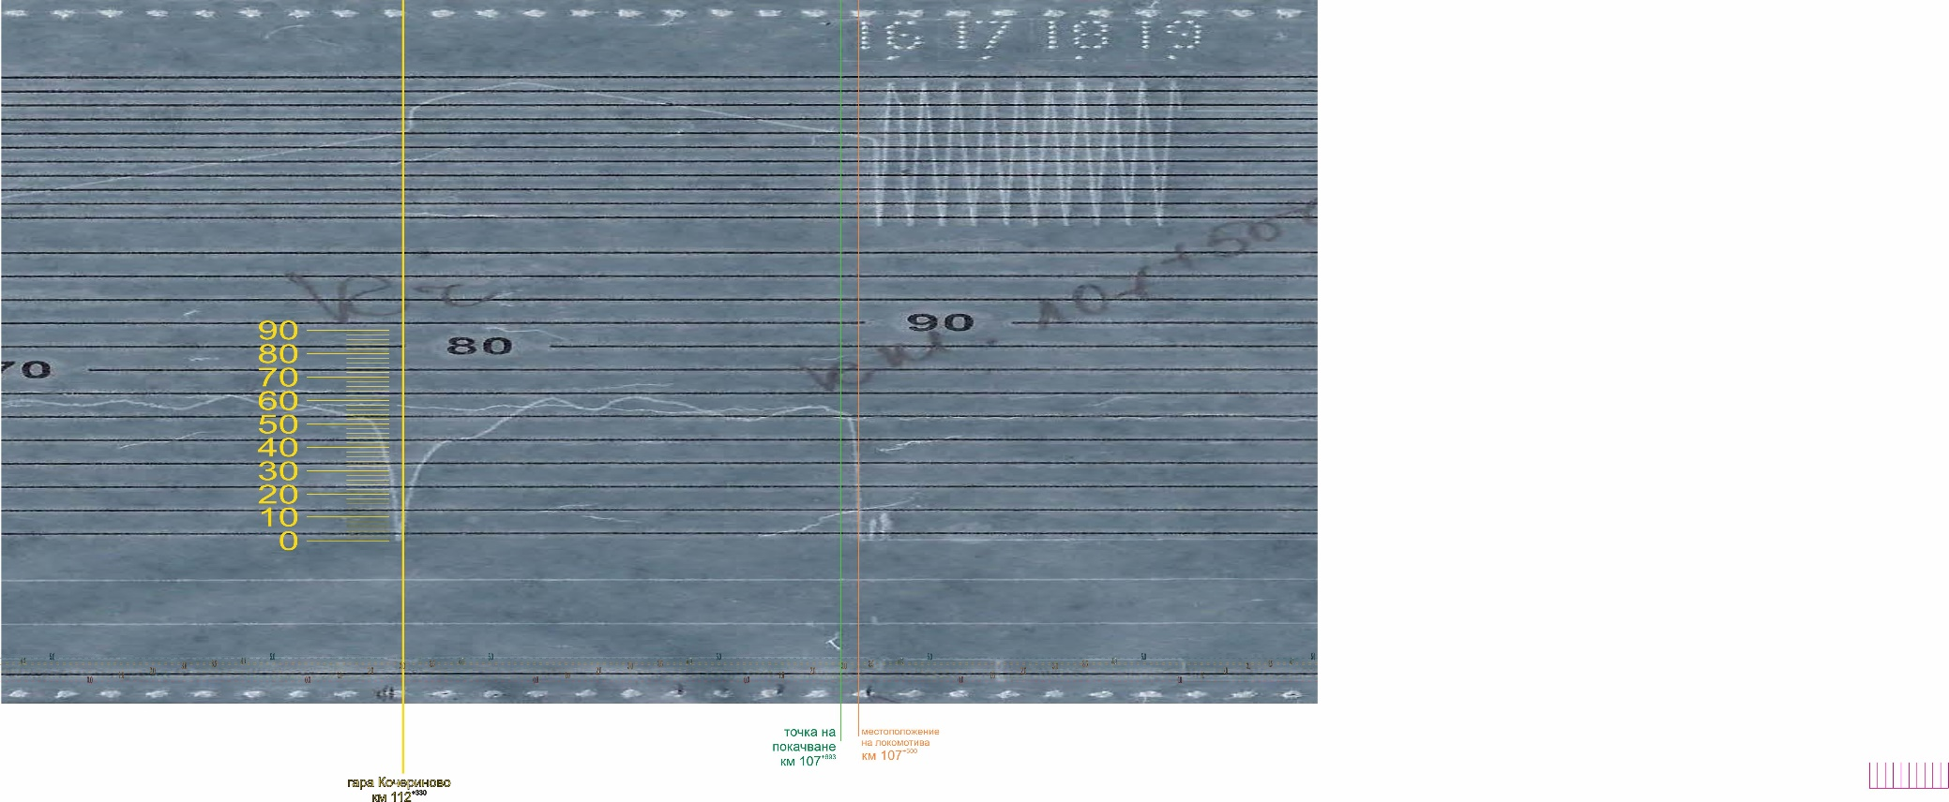
The analysis of the movement was prepared separately for the two locomotives, starting from Kocherinovo station.
Fig. 4.2. Speedometer tape of locomotive № 97520061003-1.
1
2
5
6
8
9
11
10
3
4
7
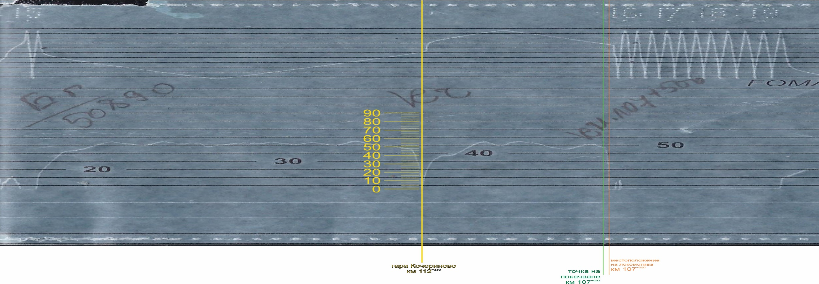
Train movement analysis under locomotive speedometer tape recording No 97520061003-1 (Figure 4.2). The locomotive is equipped with RT 9 speedometer and non-registering A16. The speedometer tape is placed in such a way that the nibs recording speed, time, air pressure in the main air duct and additional registrations are displaced in a vertical direction by about 1-2 mm, and the nibs recording the time and pressure of the air in the main air duct exceed the stylus, which also recorded the speed by about 1-2 mm (Figure 4.2, position. 1 and 2). This made it very difficult to read the information recorded on the speedometer tape and the train running analysis. As per the recording of locomotive No 97520061003-1, the train departed from Kocherinovo station at 15:38 p.m. after a stay of almost 2 minutes. After departure, it accelerated and developed a speed of 43 km/h (it was established that the shifted stylus of the speedometer was 3 km/h higher), it travelled 400 meters (Figure 4.2, pos. 3), then accelerated again, reaching a speed of 62 km/h at 15:41 p.m. after passing about 1600 meters from the departure, i.e. about km 110⁺⁷³⁰ (Figure 4.2, pos. 4). There followed a reduction in speed to 56 km/h after a further 400 meters (Figure 4.2, pos. 5), then accelerated again and reached 62 km/h at 15:42 p.m., travelled another 400 meters, i.e. about km 109⁺⁹³⁰ (Figure 4.2, pos. 6). From that moment on, the speed started again to decrease and at 15:43 p.m. after passed 1,200 metres, it reached a value of 52 km/h without using the train brake, i.e. the natural resistance of the train (Figure 4.2, pos. 7). The locomotive driver accelerated the train to a speed of 58 km/h at 15:43 p.m. after passing about 750 meters (Figure 4.2, pos. 8). From that moment on, the speed again began to decrease and again from the natural resistance of the train. That traffic regime lasted until 15:44 p.m. after traveling around 380 meters, i.e. the leading locomotive No 97520061003-1 was approximated at km 107⁺⁵⁴⁵ when derailing the 14th wagon at km 107⁺⁶⁹³ (Figure 4.2, pos. 9). The speed at that point was 54 km/h. At that location at 15:44 p.m., the speed dropped sharply to 0 km/h due to the activation of the automatic train brake by the driver (Figure 4.2, pos. 10). That was the moment when the driver took hold with the automatic train brake by dropping 1.5 bar from the main air duct, reducing the pressure there to 3.5 bar, thus carrying out a full service hold. The train was set up at km 107⁺⁵⁰⁰ at 15:44 p.m. (fig. 4.2, pos. 11).
Fig. 4.3. Speedometer tape of locomotive № 97520055155-6.
1
2
10
9
7
8
6
5
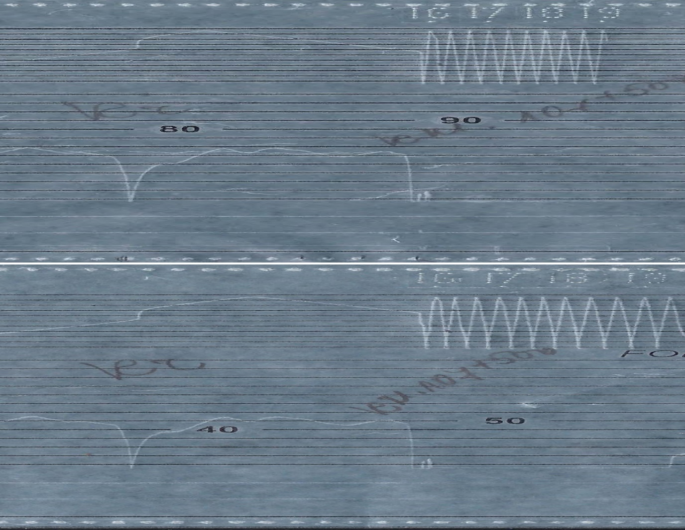
Analysis of the train running under the speedometer tape of locomotive No 98520055155-6 - train (Figure 4.3). The locomotive was equipped with a recording speedometer RT 12 and non-registering A 28 (these speedometers only recorded speed, time and travelled without recording the pressure in the main air duct). The nibs recording speed and time were located lower by about 1-2 mm in a vertical direction and the time stylus outpaced the speed stylus by about 1-2 mm again, which made it difficult to analyse the movement of IT No 50890 (Figure 4.3, point. 1 and 2). The train departed from Kocherinovo station at 15:37 p.m., accelerated to 40 km/h after about 470 meters (Figure 4.3, pos. 3), then it moved at that speed about 320 meters and again increased its speed to 56 km/h after 800 meters at 15:39 p.m. (Figure 4.3, pos. 4). Then followed a reduction of speed to 51 km/h at 15:40 p.m., after 420 meters (Fig. 4.3, pos. 5) and a new increase to 57 km/h at 15:41 p.m. after about 430 meters (Fig. 4.3, pos. 6). The speed decreased smoothly to 47 km/h at 15:43 p.m. after traveling 1200 meters (Fig. 4.3, pos. 7) and again increased to 53 km/h at 15:43 p.m. after 520 meters (Fig. 4.3, pos. 8). At that speed, the train travelled over 300 metres for about 30 seconds, and then started gradually to decrease to 48 km/h for about 20 seconds, which corresponded to km 107⁺⁵⁷⁰. At the same time, the wagons were located at km 107⁺⁶⁹³ when the 14th wagon of the train derailed (Figure 4.3, pos. 9). At 15:44 p.m. the speed began to fall sharply and after about 90 meters fell to 0 km/h at km 107⁺⁵²⁵ at 15:44 p.m. (fig. 4.3, pos. 10).
Fig. 4.4. Comparison of the speedometer tapes of locomotives №№ 98520061003-1 and 97520055155-6.
The comparative analysis of the two speedometer tapes showed some differences between the speed registrations, which may be due to the difference in wheel diameters of the two locomotives, as well as a small difference in travel, but that did not have a significant impact on the train running analysis (Figure 4.4).
      - Analysis of the technical condition of the first derailed wagon.
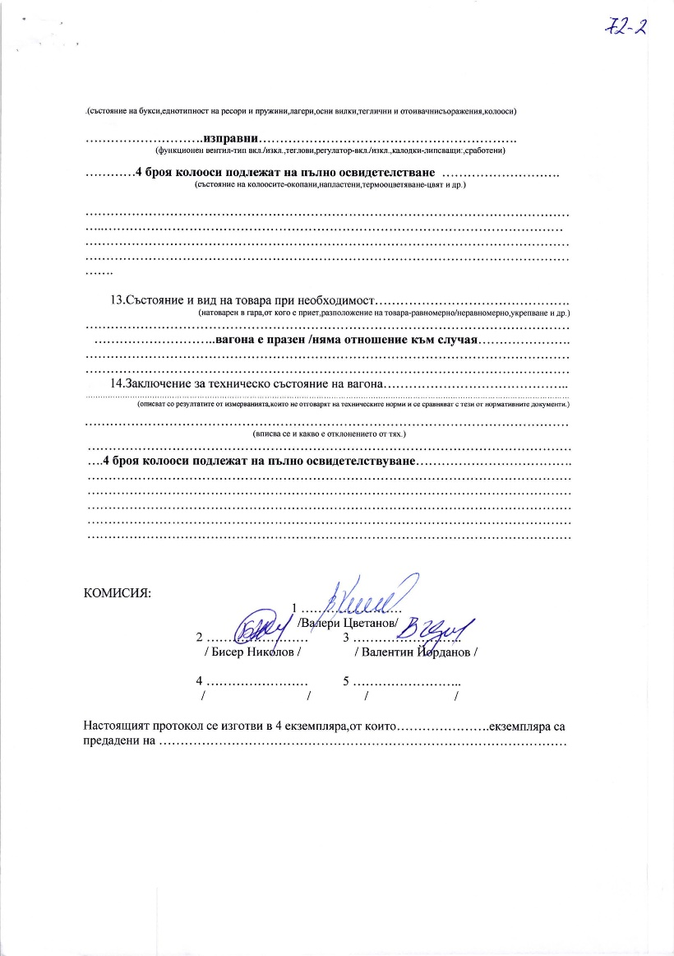
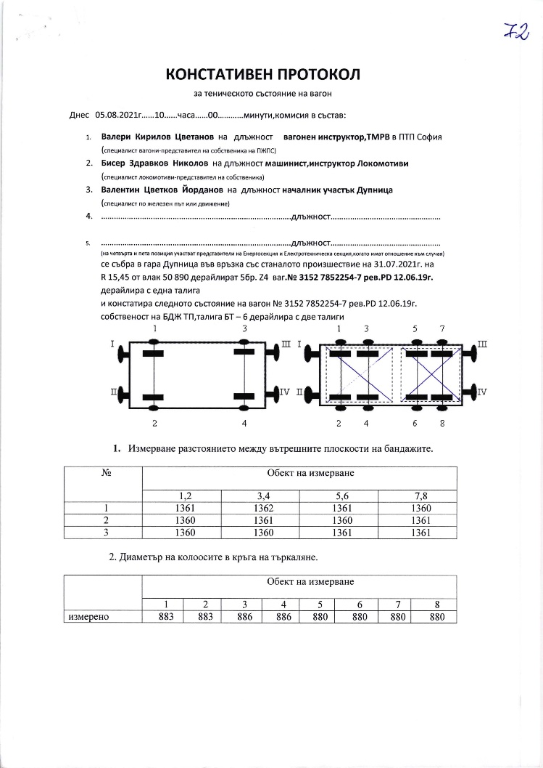
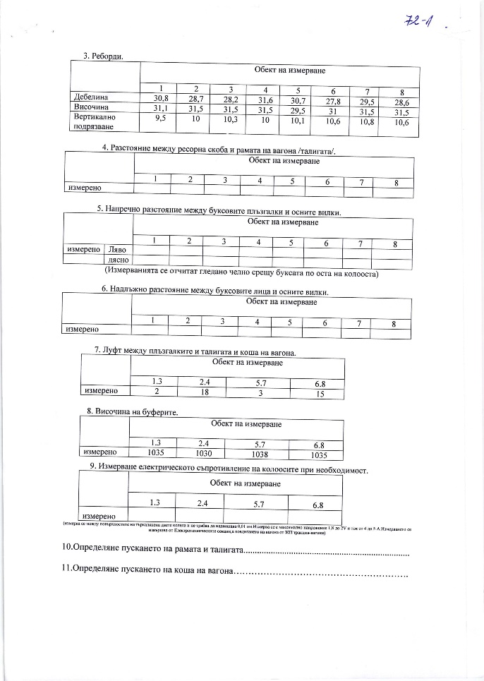
Establishing the technical condition of the fourteenth empty tank wagon first derailed as a result of horizontal casting of the track under the passing composition of IT No 50890.
Fig. 4.7. Statement of findings on the condition of wagon № 31527852254-7, 14-nth from the composition of IT № 50890, first derailed, pg. 3.
Fig. 4.5. Statement of findings on the condition of wagon № 31527852254-7, 14-nth from the composition of IT № 50890, first derailed, pg. 1.
Fig. 4.6. Statement of findings on the condition of wagon № 31527852254-7, 14-nth from the composition of IT № 50890, first derailed, pg. 2.
The Investigation Commission carried out an analysis of the condition of derailed wagons and found that wagon No 31527852254-7, which had first derailed, was technically upright before the derailment (Figure 4.5, 4.6, 4.7). It is evident from the Statement of findings that the measured values of the controlled parameters meet the requirements of the normative documents. The derailment caused minor damage to the wheel-sets and, above all, to the rolling surface of their wheels. The Commission, which drew up the Statement of findings, concluded that the wagon could be put into service after full certification of the wheel-sets.
    - Infrastructure manager.
In order to clarify the causes for the accident, it is necessary to carry out a full analysis of the technical condition of the track and the circumstances that led to the casting of the track. The train was running downhill with a gradient of 0.29 ‰.
      - Analysis of the track condition in and around the point of raising and derailment of the 14-nth wagon from the train composition.
      - Analysis of the continuously welded track.
The highest prevalence occurs in continuously welded track-reinforced type. Under the action of temperature changes the length of the end sections of the rails, called “breathing edges”, about 45 to 50 m in length. Maximum longitudinal forces appear in the fixed middle part of the rails. Their size depends on the type of rails and the magnitude of the temperature difference in relation to the neutral temperature. The length of longitudinal forces does not depend on the length of the continuously welded rail track section, so the length of the continuously welded rail track is not limited. In winter, tensile forces appear in the rails of the continuously welded track, which can cause weld breaks and breaks of the rails. In summer, due to high rail temperatures, significant longitudinal compressive forces appear which can cause the track to twist in the vertical and horizontal direction of the rails together with sleepers. The resistance to lateral displacement of the track is the friction resistance between ballast and sleepers along their lower and lateral (front) surface and ballast resistance to the foreheads of the sleepers. Therefore, for the continuously welded track, the requirements regarding the transverse profiles of the ballast prism are increased and it must not be less than 33 cm below the lower base of the sleepers. Its width at the top shall be at least 330 cm in straight sections and further enlarge to 340 cm in curves. The ballast in the inter-sleepers and in front of the foreheads must be well compacted. When performing relevant work operations when carrying out repairs, it is necessary to comply with all the requirements of the technical regulations for the planning, construction and repair of continuously welded track from 2018 of SE NRIC. When a given continuously welded track section (whether under or without a train) is twisted or there are detected signs of start of twist/distortion/casting, it is necessary to take steps to ensure neutralisation within the permitted laying interval. Also tightening of the fastening and further ballasting of the continuously welded track to the appropriate dimensions of the ballast prism. Until such operations are carried out, train speed shall be reduced to 25 km/h. The continuously welded track in the Boboshevo - Kocherinovo interstation was built at the end of November and the beginning of December 2019. The continuously welded track was built of rails type 49 kg/m with reinforced concrete sleepers C-6 and elastic fastening SKL-14, downhill 0.29 ‰ in the direction of the train movement (Figure 4.8).

The two buffer units are placed as follows:
Firs buffer unit from km 106+964 to km 106+989 with 25 m. unit.
Second buffer unit from km 108+551 to km 108+576 with 25 m. unit.
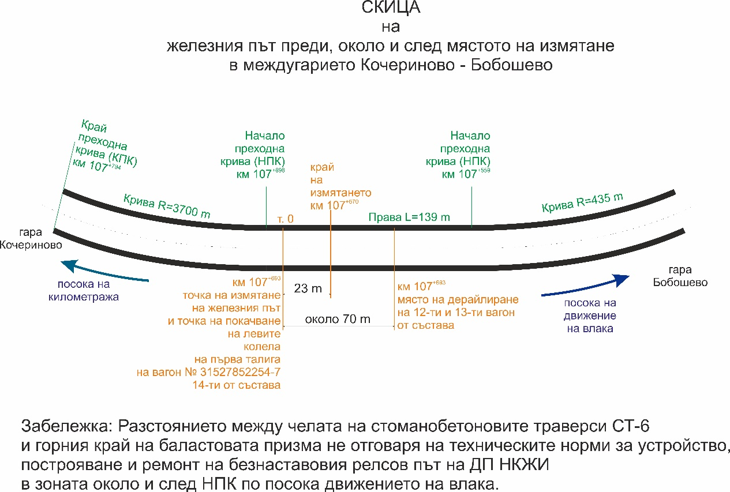
The continuously welded track is located in a second zone with a maximum permissible rail temperature of up to + 63° and a minimum of -23°, or in a temperature range of 86°
Фиг. 4.8. Скица на железния път в мястото на произшествието.
It is generally accepted that the rail temperature is about 20° higher than the air temperature at positive and identical at negative temperatures. The last neutralisation of the continuously welded track was carried out on 27.05.2020. The reported maximum temperature of the rails in the days around the derailment reached a value of 59° in that for a second zone of 63°. It is apparent from the provided statement of findings on the condition of the track before the point of casting that the track was in excellent technical condition, with deviations up to 2 mm and in track gauge + 1 mm and good axle condition. The Commission from the Statement of findings did not measure and indicate the dimensions of the ballast prism and, above all, at the point of casting against the foreheads of the sleepers.
The data submitted by the track-measuring laboratory, which measured the track on 4 August 2020, are in the norm. The defectoscopy of the rails was carried out on 05.05.2021.
Inspections were carried out by the head of section Dupnitsa on 8 and 14 July 2021, as the inspection carried out on 08.07.2021 is of the last wagon of fast train No 5622 and on 14.07.2021 in the cabin of the locomotive serving fast train No 5622.
Despite the above, on-the-spot, the Commission found that the ballast prism did not meet the technical requirements around and in the derailment zone laid down in the ‘Technical regulations for the planning, construction and repair of continuously welded track’, which led to its twisting (Figure 4.9).

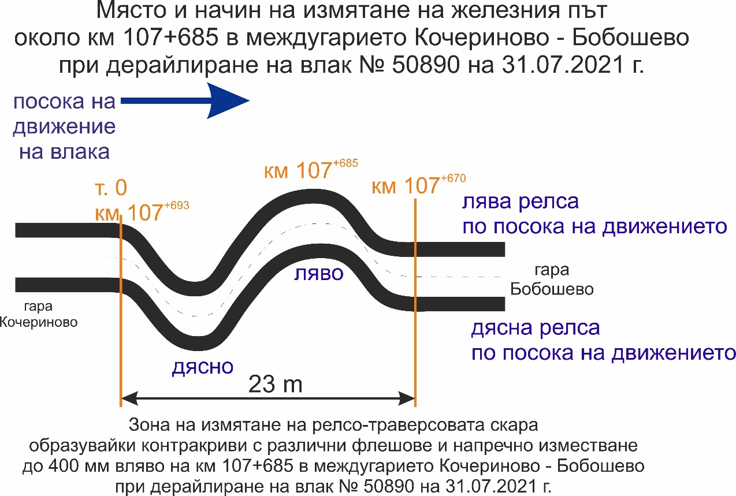
    - Entities in charge of the technical maintenance.
Fig. 4.9.
• the responsible entity for the technical maintenance of the railway infrastructure/rail track in the derailment area is Sofia railway section to “Permanent way and structures” Division, at SE NRIC;
• the rolling stock is validly registered in the National Vehicle Register. BDZ-Cargo Ltd. is the responsible entity for the maintenance of the rolling stock — locomotives and 4 of the wagons, while Cargo Trans Wagon Bulgaria AD is responsible for wagon 335279653338.
    - Manufacturers or providers of rolling stock and railway products.
Not applicable.
    - National Safety Authority.
Railway Administration Executive Agency is the National Safety Authority for railway transport in the Republic of Bulgaria.
    - Notified bodies or Risk assessment bodies.
Not applicable.
    - Certifying bodies of the entities in charge of maintenance.
The Railway Administration Executive Agency as the National Safety Authority for railway transport performs certification of the entities in charge of the vehicles maintenance (ECM) in accordance with Directive 2004/49/EC and Regulation (EU) 445/2011, as per Ordinance No 59 on the railway transport safety management and on the maintenance functions in accordance with Directive 2004/49/EC and Regulation (EU) 445/2011.
From June 16, 2020 the RAEA performs certification of the ECM as per the Commission Implementing Regulation (EU) 2019/779 of 16 May 2019 laying down detailed provisions on a system of certification of entities in charge of maintenance of vehicles pursuant to Directive (EU) 2016/798 of the European Parliament and of the Council and repealing Commission Regulation (EU) No 445/2011

    - Persons or entities involved in the event, documented or not in the respective safety management systems or indicated in register.
Not applicable.
  - Rolling stock and technical facilities:
    - Factors, deriving from the design of the rolling stock, railway infrastructure or technical facilities.
Not applicable.
    - Factors deriving from the installation and placing into service of the rolling stock, railway infrastructure and technical facilities.
Not applicable.
    - Factors deriving from manufacturers or another provider of railway products.
Not applicable.
    - Factors, deriving from the technical maintenance and/or modification of the rolling stock or the technical facilities.
Not applicable.
    - Factors due to the entity in charge of the technical maintenance, workshops for technical maintenance and other technical maintenance service providers.
Not applicable.
    - Other factors or consequences considered as involved within the investigation objectives.
      - Wagon loading
Not applicable.
  - Human factor:
    - Individual human characteristics:
      - Training and development, including skills and experience.
Railway undertaking:
• Locomotive driver of locomotive № 97520061003-1 – License № 9081 for obtaining professional qualification „Locomotive driver of electric locomotives“, training performed within the period 12.05.÷11.07.2008, issued by Professional Training Center (PTC) of Bulgarian State Railways (BDZ);
Locomotive driving license BG 71 2017 0694 issued by RAEA;
License № 691 for position Locomotive driver and train work at PTP – Sofia dated 30.09.2016.
• Assistant locomotive driver of locomotive № 97520061003-1 – License № 4552 for obtaining professional qualification for „Assistant locomotive driver of electric locomotives“, training performed within the period 12.06.÷08.09.2006, issued by Professional Training Center (PTC) of Bulgarian State Railways (BDZ);
License № 31-D for position Assistant locomotive driver and train work at PTP – Sofia dated 20.11.2013.
• Locomotive driver of locomotive № 98520055155-8 – Diploma № 21713 for obtaining professional qualification ,,Railway machinery – diesel locomotives“, training carried out in the period 28.08.1983 ÷ 23.08.1986 issued by VNVTU ,,Todor Kableshkov“.
Locomotive driving license BG 71 2017 1063 issued by RAEA;
License № 469 for position Locomotive driver and train work at PTP – Sofia dated 19.07.2011.
Railway infrastructure:
• Traffic manager in Kocherinovo station – Certificate of qualification № 1697 for, Traffic manager“, training performed within the period 02.08.÷08.11.2004 issued by the Professional Training Center at NRIC;
Certificate № 2545 for position Traffic manager at TOSAD – Sofia from 08.10.2007.
• Head of rail track section Dupnitsa – Diploma № 18101 for “Technician on maintenance and construction of railway lines and switches“, training performed within the period 28.08.1976 ÷08.06.1979, issued by PRI “Todor Kableshkov” – Sofia;
Certificate № 43 for position Head of section – RS Sofia from 14.03.2016.
      - Medical and personal circumstances, which influence the event, including the presence of physical and psychological stress.
Railway undertaking:
• Locomotive driver of locomotive № 97520061003-1:
Single information health dossier № 630 for periodic medical exam dated 26.02.2021, issued by Sofia Multi-profile Transport Hospital:
Conclusion: suitable for locomotive driver.
Physiological exam № 589/23.04.2018, issued by Laboratory for physiological expertise at Sofia Multi-profile Transport Hospital for locomotive driver. Conclusion: accepted for a 5-year period.
• Assistant locomotive driver of locomotive № 97520061003-1:
Single information health dossier № 212 for periodic medical exam dated 04.02.2021, issued by Sofia Multi-profile Transport Hospital:
Conclusion: suitable for assistant locomotive driver.
Physiological exam № 795/21.07.2021 issued by Laboratory for physiological expertise at Sofia Multi-profile Transport Hospital for assistant locomotive driver. Conclusion: accepted for a 3-year period.
• Locomotive driver of locomotive № 98520055155-8:
Single information health dossier № 381 for periodic medical exam dated 25.02.2021, issued by Sofia Multi-profile Transport Hospital:
Conclusion: suitable for locomotive driver.
.
Physiological exam № 1386/12.11.2018 issued by Laboratory for physiological expertise at Sofia Multi-profile Transport Hospital for locomotive driver. Conclusion: accepted for a 3-year period.
.
Railway infrastructure:
• Traffic manager in Kocherinovo station:
Single information health dossier № 1227 for periodic medical exam dated 23.06.2021, issued by Sofia Multi-profile Transport Hospital:
Conclusion: suitable for traffic manager.
.
Physiological exam № 857/04.08.2020 issued by Laboratory for physiological expertise at Sofia Multi-profile Transport Hospital for traffic manager. Conclusion: accepted for a 1-year period.
• Head of Dupnitsa railway section:
It has been established that the head of the railway section did not undergo periodic medical certification required under Article 7 of Regulation No 54 of 2 June 2003 on the medical and psychological requirements for staff carrying out the transport of passengers and goods by rail and the associated activities and for carrying out pre-way medical examinations.

      - Fatigue.
Railway undertaking:
• Locomotive driver of locomotive № 97520061003-1:
Break/rest: from 16:30 p.m. on 30.07.2021 to 06:35 a.m. on 31.07.2021 (14 hours and 05 minutes);
• Assistant locomotive driver of locomotive № 97520061003-1:
Break/rest: from 07:00 a.m. on 30.07.2021 to 06:35 a.m. on 31.07.2021. (23 hours and 35 minutes);
• Locomotive driver of locomotive № 98520055155-6:
Break/rest: from 00:00 a.m. on 19.07.2021 to 06:35 a.m. on 31.07.2021 (408 hours and 35 minutes);
Railway infrastructure:
• Traffic manager Kocherinovo station:
Break/rest: from 06:50 a.m. on 29.07.2021 to 06:50 a.m. on 31.07.2021 (48 hours and 00 minutes);
• Head of Dupnitsa railway section:
Full working time 40 hours a week.
Break/rest: from 16:45 p.m. on 30.07.2021 to 16:10 p.m. on 31.07.2021 (23 hours and 35 minutes);
      - Motivation and attitudes.
Not applicable.
    - Work related factors:
      - Tasks planning.
BDZ-Cargo Ltd. performs the freight traffic under a Plan for train composition and they are carried out as per the Train Operation Schedule.
      - Constructive particularities of the facilities that influence the connection human-machine.
Not applicable.
      - Communication means.
Not applicable.
      - Practices and processes.
Not applicable.
      - Operation rules, local instructions, staff requirements, prescriptions for technical maintenance and applicable standards.
Application of the national normative acts and internal standards.
      - Working time of the involved personnel.
In accordance with the requirements of the normative acts - Labour Code and Ordinance № 50 of 28.12.2001 for the working hours of the managerial and executive staff, engaged in providing the transportation of passengers and freights in the railway transport. The staff of both entities works in shifts/suspension (when servicing a train or a vehicle - with a variable start and different working hours), in which a summary calculation of the working time shift in a 12-hour work shift and full working week are applied.
      - Risk treatment practices.
SE NRIC applies safety procedure SP 2.09 „Methods of evaluation, assessment and management of the risk „version 05 effective from 01.03.2019, which is part of the SMS.
BDZ Cargo Ltd. Applies procedure „Methods of evaluation and assessment of the risk in BDZ Cargo Ltd.“ effective from 2013 part of SMS.
    - Context, machinery, equipment and indications for shaping the working practices
Not applicable.
    - Organizational factors and tasks:
      - Planning of the working force and the working load.
As per the requirements of the normative documents and best practices.
      - Communications, information and teamwork.
Not applicable.
      - Recruitment, staffing requirements, resources.
Not applicable.
      - Implementation management and supervision.
Not applicable.
      - Compensation (remuneration).
Not applicable.
      - Leadership, powers related issues.
Not applicable.
      - Organizational culture.
Not applicable.
      - Legal issues (including the respective European and national rules and provisions).
Not applicable.
      - Regulatory framework conditions and safety management system application.
Railway undertaking.
- Directive (EU) 2016/798 of the European Parliament and of the Council of 11 May 2016 on railway safety;
- Commission Delegated Regulation (EU) 2018/762 of 8 March 2018 establishing common safety methods on safety management system requirements pursuant to Directive (EU) 2016/798 of the European Parliament and of the Council and repealing Commission Regulations (EU) No 1158/2010 and (EU) No 1169/2010
- COMMISSION IMPLEMENTING REGULATION (EU) 2019/779 of 16 May 2019 laying down detailed provisions on a system of certification of entities in charge of maintenance of vehicles pursuant to Directive (EU) 2016/798 of the European Parliament and of the Council and repealing Commission Regulation (EU) No 445/2011;
- COMMISSION IMPLEMENTING REGULATION (EU) No 402/2013 of 30 April 2013 on the common safety method for risk evaluation and assessment and repealing Regulation (EC) No 352/2009;
- Railway Transport Act;
- ORDINANCE No 59 dated 5.12.2006 on the railway transport safety management.
- TOR and TOSAR.
Railway infrastructure.
- Directive (EU) 2016/798 of the European Parliament and of the Council of 11 May 2016 on railway safety;
- Commission Delegated Regulation (EU) 2018/762 of 8 March 2018 establishing common safety methods on safety management system requirements pursuant to Directive (EU) 2016/798 of the European Parliament and of the Council and repealing Commission Regulations (EU) No 1158/2010 and (EU) No 1169/2010
- COMMISSION IMPLEMENTING REGULATION (EU) 2019/779 of 16 May 2019 laying down detailed provisions on a system of certification of entities in charge of maintenance of vehicles pursuant to Directive (EU) 2016/798 of the European Parliament and of the Council and repealing Commission Regulation (EU) No 445/2011;
- COMMISSION IMPLEMENTING REGULATION (EU) No 402/2013 of 30 April 2013 on the common safety method for risk evaluation and assessment and repealing Regulation (EC) No 352/2009;
- Railway Transport Act;
- ORDINANCE No 59 dated 5.12.2006 on the railway transport safety management.
- TOR and TOSAR.
    - Environmental factors:
      - Labour conditions (noise, illumination, vibrations).
Not applicable.
      - Meteorological and geographic conditions.
Not applicable.
      - Construction works, performed on the spot or in very proximity.
Not applicable.
    - Any other significant factor for the investigation objectives.
Not applicable.
  - Feedback and control mechanisms, including risk and safety management, as well as monitoring processes:
    - Regulatory framework conditions.
Commission Delegated Regulation (EU) 2018/761 of 16 February 2018 establishing common safety methods for supervision by national safety authorities after the issue of a single safety certificate or a safety authorisation pursuant to Directive (EU) 2016/798 of the European Parliament and of the Council and repealing Commission Regulation (EU) No 1077/2012;
ORDINANCE No 59 of 5.12.2006 on the railway transport safety management.
    - Processes, methods and results from the activities on the risk assessment and monitoring that the involved entities performed:
      - Railway undertakings.
BDZ Cargo Ltd. Applies procedure „Methods of evaluation and assessment of the risk in BDZ Cargo Ltd.“ effective from 2013 part of SMS.
      - Railway infrastructure.
SE NRIC applies a safety procedure SP 2.09 „Methods of risk evaluation and assessment „version 05 effective from 01.03.2019, which is a part of SMS.
      - Entities in charge of the technical maintenance.
SE NRIC and BDZ Cargo Ltd are certified ECM.
SE NRIC applies a safety procedure SP 2.09 „Methods of risk evaluation and assessment „version 05 effective from 01.03.2019, which is a part of SMS.
BDZ Cargo Ltd. Applies procedure „Methods of evaluation and assessment of the risk in BDZ Cargo Ltd.“ effective from 2013 part of SMS.
      - Manufacturers and all other participants.
Not applicable.
      - Reports on independent risk assessment.
There has not been performed an assessment by independent Assessment Body (AsBo) on changes/modifications performed in operational conditions and factors that refer to the occurred accident.
    - Safety Management System of the involved:
      - Railway Undertakings.
The last annual planning supervision of the SMS of BDZ Cargo Ltd was carried out between 13 January 2020 and 31 January 2020. In 2020, BDZ Cargo Ltd also carried out several specialised audits — in relation to communication with train dispatchers of SE NRIC and on complaints about incorrectly reported delays
      - Railway Infrastructure Managers.
The latest annual planned supervision of the SMS of SE NRIC was performed in the period from 19.10.2020 to 30.10.2020
    - Safety Management System of the entities in charge of the technical maintenance.
Not applicable.
    - Results from the supervision, performed by the National Safety Authority.
The results from the performed audits and inspections referring the functionality of the Safety Management System of SE NRIC and BDZ Cargo Ltd. as per the requirements of Regulation (EU) 2018/761, Regulation (EU) No 1169/2010, Ordinance No 56 and Ordinance No 59 on respect of the specific requirements of the European legislation and national rules for design, maintenance and operation of the managed railway infrastructure demonstrate that the entities maintain SMS and are able to respect the requirements, envisaged in the respective normative documents.
    - Permits, certificates and assessment reports, provided by the National Safety Authority or other Conformity Assessment Bodies:
      - Safety certificates of the involved railway infrastructure managers.
Safety Authorization No BG 21/2018/0001 valid from 01.07.2018 to 30.06.2023.
      - Safety certificates of the involved railway undertakings.
Safety certificate part А BG 11 2017 0008, valid to 30.12.2022;
Safety certificate part B BG 12 2017 0008, valid to 30.12.2022;
      - Authorizations for placing in service of permanently fixed equipment and permits for placing on the market of vehicles.
Not applicable.
      - Entities in charge of the technical maintenance.
BDZ Cargo Ltd. has an ECM certificate for railway vehicles BGRA/2017/0003 valid to 30.12.2022;
SE NRIC is responsible for the repair, maintenance and operation of the national railway infrastructure.
    - Other system factors.
Not applicable.
  - Previous similar cases.
Similar cases were investigated in similar and identical circumstances, which were the subject of reports in a form appropriate to the type and severity of the accident in which safety recommendations were also formulated.

- Conclusions
  - Summary of the analysis for the event causes.
The Investigation Commission visited the location of the accident several times, took note of the documentation collected and provided on the repair and maintenance of continuously welded rail track before and after the accident. Repair of the continuously welded rail track was carried out as a matter of necessity after the signal from the locomotive driver of fast train No 5624 on 29.07. 2021 at 20:00 p.m. along Kocherinovo — Boboshevo interstation, who saw a deteriorated technical condition on the railway track, reducing the speed and passing unimpeded with a strong locomotive swing.
The Investigation Commission examined in detail the documentation provided on the technical condition of the five empty tank wagons №№81527852130-8, 33527965338, 31527852254-7, 31527851994-9, 82527851614-1, and more specifically the 14th tank wagon, first derailed.
The Investigation Commission took note of the situation on the spot, carried out several detailed and careful inspections of the track, and conducted an interview with the personnel involved in the accident. Analysed all the circumstances of the derailment and made a summary of the accident.
The derailment occurred as a result of the deteriorated technical condition of the continuously welded rail track (moving horizontally across the axis of the track with amplitudes of up to 400 mm left/right) taking into account the parameters measured after the occurrence of the accident. The poor reinforcement of the track after the repair (HTM 08322, STM No 99529423001-7), combined with the high pressure on the rails resulting from the high daytime temperatures (39 °C of the air) caused unacceptable deviations horizontally along the track axis. Following the operation of the tamping machine, bringing the track along the axis has reduced the adhesion between the sleeper gird and the ballast prism, which led to a weakening of the track. During the repair of the track, there was no neutralisation and additional ballasting of the striped sleepers of the track. Because of the large additional longitudinal forces that emerged, the track under the IT No 50890 was twisted
  - Undertaken measures after the event occurrence.
The railway infrastructure manager has taken measures to neutralize and ballast the continuously welded track in the area of the accident. During the repairs of the track, the speed was reduced to 25 km/h and was then recovered under schedule.
The derailed wagons №№81527852130-8 - 12nd, 335279653380-13rd, 31527852254-7- 14th, 82527851614-1 -16th, were of the composition of the train, with slight damage, repaired at the Mezdra WF in the period 10.08-16.08.2021. Wagon No 31527851994-9-15th, had a burst tank and is located in Dupnitsa station, unfit for operation
  - Additional findings.
There are no any.

- Safety recommendations
In order to improve the safety in the rail transport, the Investigation Commission at NAMRATIB proposes to the Railway Administration Executive Agency the following safety recommendations adapted to SE NRIC and „BDZ-Cargo“ Ltd.
• Recommendation 1 proposes that SE NRIC and BDZ Cargo Ltd. shall acquaint the interested staff with the content of this report.
• Recommendation 2 proposes SE NRIC to strengthen the control on places with continuously welded rail track for strict compliance with the “Technical norms for the planning, construction and repair of continuously welded rail track.
• Recommendation 3 proposes that SE NRIC strengthen the control of the state of the continuously welded rail track, especially at extreme temperatures during the summer season based on weather forecasts, by carrying out additional on-the-spot checks and inspections. Particular attention shall be paid to the ballasting and fastening of the rail track.
With reference to the requirements of art. 24, paragraph 2 of Directive (ЕU) 2016/798, art. 115k, paragraph 4 of the Railway Transport Act, art. 91, paragraph 3 and art. 94 par. 1 and par. 4 of Ordinance No 59 dated 5.12.2006, the Deputy President of the Administrative Board of the NAMRTAIB with competence to investigate railway accidents submits a final report to the entities of the event and the Railway Administration Executive Agency, containing information from the investigation performed for the causes of the railway accident and safety recommendations for improving the railway transport safety.
The Deputy President of the Administrative Board of the NAMRTAIB, proposes a final report with safety recommendations on 14.12.2021.

Chairperson:
Dr. Eng. Boycho Skrobanski
Deputy President of the NAMRTAIB AB

